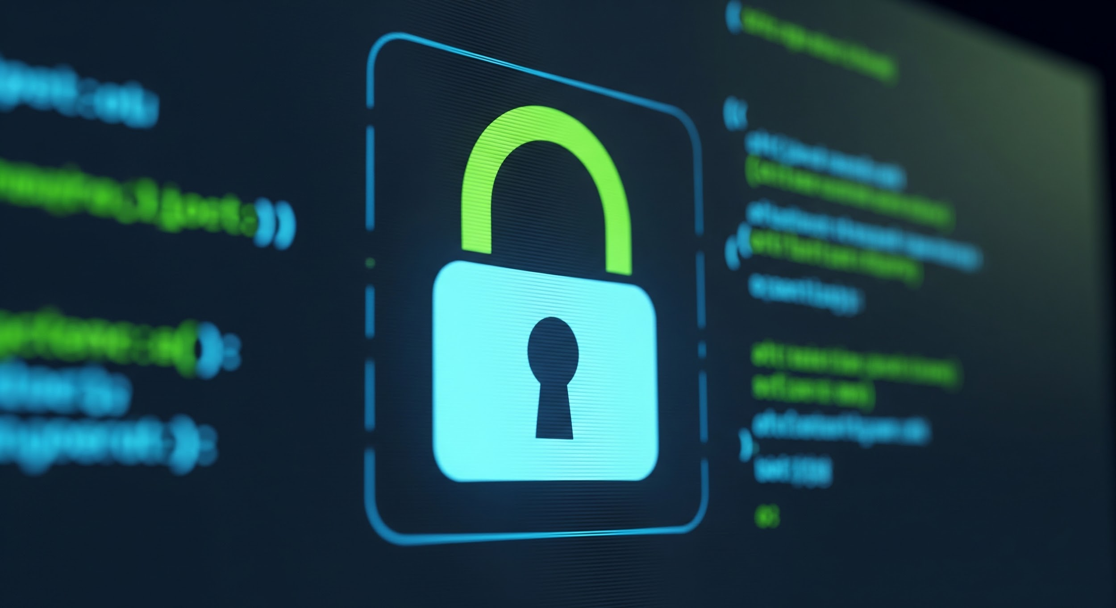

Part B (Prevention): Digital Safety Checklist
This checklist provides 8 actionable tips to enhance digital safety and prevent online fraud.

Tip No. | Category | Actionable Tip
1 | Account Security | Use a strong, unique password for every online account and enable two-factor authentication (2FA) wherever possible.
2 | Phishing/Scams | Never click on suspicious links or attachments in emails or text messages, especially if they request personal or financial information.
3 | Software Updates | Regularly update your operating system, browser, and all applications to ensure you have the latest security patches.
4 | Public Wi-Fi | Avoid conducting financial transactions or logging into sensitive accounts while using public or unsecured Wi-Fi networks.
5 | UPI/Financial Safety | Never share your UPI PIN with anyone, not even for receiving money. The PIN is only required when sending funds.
6 | UPI/Financial Safety | Use 'Verify Beneficiary' when adding a new recipient on any payment app to ensure the funds are going to the correct person/account.
7 | Device Security | Install and maintain reliable antivirus and anti-malware software on all your devices.
8 | Fraud Response | If you have been a victim of financial cyber fraud, immediately call the National Cybercrime Reporting Portal's financial fraud helpline: 1930.

